学术报告通知
报告题目: Molecular Solar Thermal Energy Storage Systems
报 告 人: Prof. Kasper Moth-Poulsen (Chalmers University of Technology, Sweden)
报告时间: 2019年4月15日(周一)，下午14:00-15:00
报告地点: 实验三楼102会议室

报告人简介：
Kasper Moth-Poulsen is a professor in nanomaterials chemistry at Chalmers University of Technology. His research group focuses on the design and synthesis of new self-assembled materials. They make materials from nanoparticles, nanorods and tailor-made small molecules for a broad range of applications ranging from single molecule electronics to sensors, and renewable energy. KMP is the recipient of an ERC starting grant, and is a SSF future research leader and a Wallenberg Academy Fellow. KMP has since 2005 published 95 research papers that has been cited 3230 times according to google scholar. He has submitted 3 patent applications related to solar energy research. His work on solar energy storage has been feature on national TV, and internationally (among others) by Thompson Reuters TV and NBC Mach.
Group homepage: www.moth-poulsen.se

报告摘要：Norbornadiene (NBD) and its derivatives undergo photoisomerisation to the highly strained quadricyclane (QC). The system is being optimized towards solar energy storage applications, and the best NBD derivatives fulfil several of the requirements for a functional system,¹⁻⁵ such as high photoizomerisation quantum yield (up to 99%), red-shifted absorption, high energy storage densities (up to 1 MJ/kg)³, very long half-life, up to 18 years of storage time² and a record temperature gradient of 63°C (83°C measured)¹. However, several key challenges remain; for example, substituents needed to improve the solar spectrum match and quantum yield of unsubstituted norbornadiene typically reduce the energy density. While unsubstituted norbornadiene is a liquid, most of the higher performing derivatives are solids at room temperature, and the characterization has typically only been done in dilute solution for practical reasons.^{4,5} The use of solvents dilutes the effective energy densities of the systems significantly. In this presentation, our efforts in improving the NBD/QC system towards efficient energy storage systems including new ways to improve solar spectrum match and energy storage time without making compromises on energy storage densities will be presented.5 Moreover, I will present device concepts for lab scale demonstration of solar energy capture (up to 900 cm2 devices) as well as heat release devices based on molecular photoswitches that perhaps one day can be used in real life application in solar energy storage. Finally, I will present systems that can be photoswitched between two states creating alternative uses of the system as a molecular
logic “keypad lock” (fig. 1 right).⁶
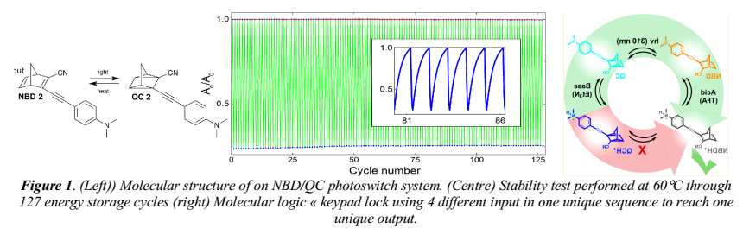
Referemce:
- Zhihang Wang, Anna Roffey, Raul Losantos, Anders Lennartson, Martyn Jevric, Anne U. Petersen, Maria Quant, Ambra Dreos, Xin Wen, Diego Sampedro, Karl Börjesson and Kasper Moth-Poulsen. "Macroscopic Heat Release in a Molecular Solar Thermal Energy Storage System" Energy and Environmental Science, 2019, 12, 187-193. (cover)
- Martyn Jevric, Anne U. Petersen, Mads Mansø, Sandeep Kumar Singh, Zhihang Wang, Ambra Dreos, Christopher Sumby, Mogens Brøndsted Nielsen, Karl Börjesson, Paul Erhart, and Kasper Moth-Poulsen "Norbornadiene-based photoswitches with exceptional combination of solar spectrum match and long term energy storage" Chemistry a European Journal 2018 24 (49), 12767-12772. (frontispiece)
- Mads Mansø, Anne Ugleholdt Petersen, Zhihang Wang, Paul Erhart, Mogens Brøndsted Nielsen, Kasper MothPoulsen "Molecular Solar Thermal Energy Storage in photoswitch oligomers increases energy densities and storage times" Nature Communications 2018, 9:1945.
- Ambra Dreos, Zhihang Wang, Jonas Udmark, Anna Ström, Paul Erhart, Karl Börjesson, Mogens Brøndsted Nielsen and Kasper Moth-Poulsen "Liquid Norbornadiene Photoswitches for Solar Energy Storage" Advanced Energy Mater. 2018, 8 (18), 1703401. (cover)
- Ambra Dreos, Karl Börjesson, Zhihang Wang, Anna Roffey, Zack Norwood, Duncan Kushnir and Kasper MothPoulsen "Exploring the potential of a hybrid device combining solar water heating and molecular solar thermal energy storage" Energy and Environmental Science 2017, 10, 728-734. (cover)
- Ambra Dreos, Zhihang Wang, Behabitu Ergette Tebikachew, Kasper Moth-Poulsen, and Joakim Andréasson. "A Three-Input Molecular Keypad Lock Based on a Norbornadiene-Quadricyclane Photoswitch" J. Physical Chemistry Letters 2018 9, 6174–6178.

